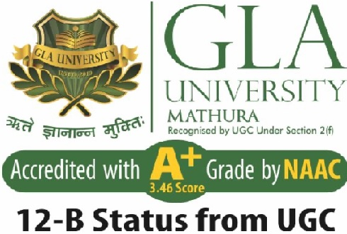
Department of Computer Engineering and Applications

GLA University, 17 km Stone, NH#2, Mathura-Delhi Road, P.O. Chaumuhan, Mathura-281406 (U.P.)

Declaration

I hereby declare that the work which is being presented in the B.Tech. Project “Resume Analyzer”, in partial fulfillment of the requirements for the award of the Bachelor of Technology in Computer Science and Engineering and submitted to the Department of Computer Engineering and Applications of GLA University, Mathura, is an authentic record of my own work carried under the supervision of Dr. Mayank Srivastava.
The contents of this project report, in full or in parts, have not been submitted to any other Institute or University for the award of any degree.

Sign ______________________ Sign ______________________
Name of Student: Kaustubh Dubey Name of Student: Shreyash Varshney
University Roll No.:201500332 University Roll No.:201500675

Certificate

This is to certify that the above statements made by the candidate are correct to the best of my/our knowledge and belief.

_______________________

Supervisor
(Dr. Mayank Srivastava)
Designation of Supervisor
Dept. of Computer Engg, & App.

______________________ ______________________

Project Co-ordinator Program Co-ordinator
(Dr. Mayank Srivastava) (Mr. Jitesh Kumar Bhatia)
Associate Professor Assistant Professor
Dept. of Computer Engg, & App. Dept. of Computer Engg, & App.

Date:

